Name _____________________________
8th Grade Historical Fiction Novel Project - Step One & Two Directions
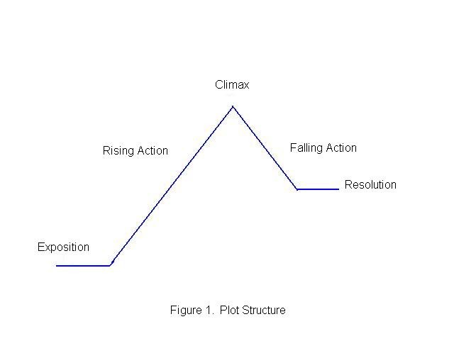
1) Find and get your historical fiction novel
okayed by ___________________________
* Be sure the historical fiction novel is set in
America and takes place between 1607
(the founding of Jamestown) and the 1880s
(when people move west following the
Civil War and Era of Reconstruction).

* Be sure to choose a historical fiction novel
that is a minimum of 200 pages and contains
topics that are significant to the era and also
have impacts on today. For step three your will
be researching to find out more about these,
and for step four, you will be writing a paper.

2) Read your historical fiction novel by ____________________________________
3) Create a typed plot line (not a diagram as seen above). Include the following in the order given, title the parts, and describe in sentences:
Exposition - (1) Establish the setting, (2) develop characters, and (3) introduce issues characters face in the exposition.
Rising Action – Give eight important actions and/or events that are problematic and/or seemed accurate to the time era.
Climax – Describe the turning point/high point.
Falling Action- Describe how actions and/or events have calmed down.
Resolution – Describe how the story was wrapped up.
Due date for step three: ____________________________________ * Hand in already printed out or share with Mrs.S on Google Docs.

Step 3 Example
The Journey of Bessie Jones - by Sam Kintley
Exposition - The setting of my historical fiction novel took place in 1850. This was after the 1849 Gold Rush in California. The protagonist, a 12 year old girl named Bessie Jones was traveling with her father Albert, her mother Aster, and her four-year-old twin brothers Timothy and James across the Great Plains to where Bessie’s Uncle Douglas found gold. Starting out, the family didn’t know what to expect during the trip. They packed as much of their belongings as they could on their Conestoga wagon, but began to realize what they though was important really wasn’t.
Rising Action - (1) The Jones family waited until they thought the spring rains were over to set out for their trip west. Less than a week into their travels, it began to rain again. They found themselves knee deep in mud with the wagon wheels stuck as well. The whole wagon had to be unpacked to try to free the wagon. It was another week and a half before they could get going again.
(2) They traveled on for another few days, crossing small streams and having to pull the wagon across by whipping the horses. Bessie, an animal lover, ran off after seeing this for the first time and had to be consoled to the fact the animals were no longer pets.
(3) The family eventually reached …
(4) Food was running low…
(5) Timothy contracts typhoid fever…
Etc.
High Point - The Jones family took so long getting across the Great Plains, that they didn’t get through the Rocky Mountains before snow began setting in. Numb and blinded by a blizzard, ….
Falling Action - Bessie sees a cabin as she stumbles down the mountainside. Crying and dragging her bloody, frozen feet she makes it to the door. Feebly knocking, a mountain man named Josiah Jenkins catches her as she loses consciousness….
Resolution - Bessie makes it to California and finds her Uncle Douglas and again has a family….

